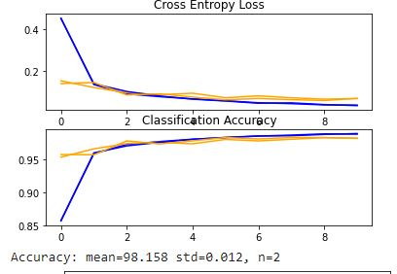Question # 1: Part one:

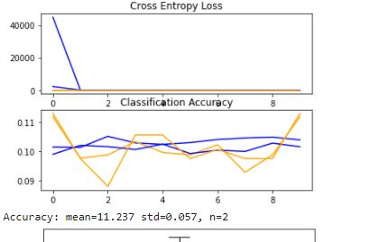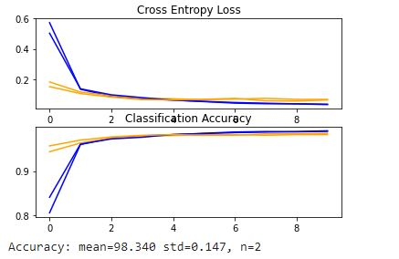

Figure 2 A regular CNN with SGD optimizer and 0.01 learning rate and batch size = 128

Figure1 A regular CNN with SGD optimizer and 0.01 learning rate

Figure 3 A regular CNN with Adam optimizer and 0.1 learning rate and batch size = 64

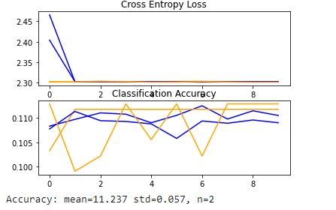

Figure 4 A regular CNN with RMSProp optimizer and 0.01 learning rate and batch size = 64

Question 1 part 2:

Figure 5 An inverted CNN with SGD optimizer and 0.01 learning rate and batch size = 64

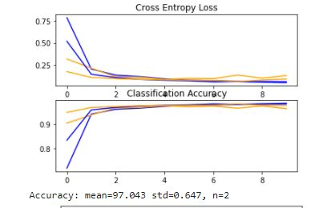

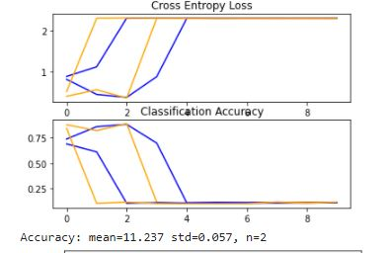

Figure 6 An inverted CNN with Adam optimizer and 0.01 learning rate and batch size = 64

Figure 7 An inverted CNN with RMSProp optimizer and 0.01 learning rate and batch size = 64

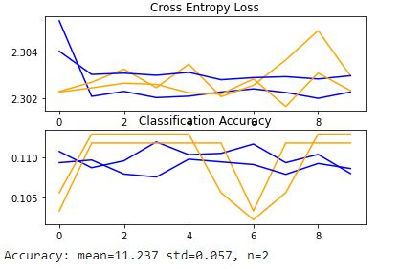

Figure 8 An inverted CNN with RMSProp optimizer and 0.1 learning rate and batch size = 64

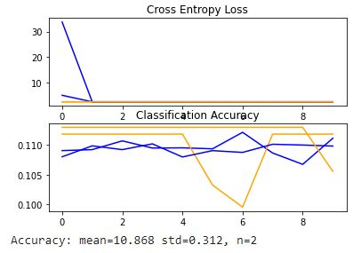

Question 1 part 3:

Figure 9 An hour-glass shaped CNN with SGD optimizer and 0.01 learning rate and batch size = 64

